**<https://ayojok.com>**

**Report [2-4-2019]**

**User-end**

1. Login [checking for new user] R&D
   1. Google
   2. Facebook
2. Home page:
   1. Confirm query [icon should be deleted] [done]
      1. Number of confirm query visible on the head of users’ name [ done ]
   2. My inbox => Inbox [change the text] [done]
   3. Footer => partners => highlights by some color [Gold color] [done]
3. My-query page:
   1. All the vendors’ text should be changed by service providers. [done]
   2. Clear-list [remove] [done]
4. Order-List => changed to Booking List [ text changed ] [done]
   1. According to this change => should change every order list to booking list. [done]
   2. Need text [from Shajal bhai] (about uses of order-list)
   3. Search box + pagination helper number [delete] [done]
5. Payment:
   1. Text changed [You haven’t booking anything. After booking you can see your payment list here.] [done]
6. Inbox page:
   1. Read spelling check [done]
   2. Short note remove. [done]
7. New Page : [Contact Us] for ayojok.com
   1. Message [admin panel]
   2. Targeting point should be in footer somewhere.
8. Event coordinator => booking form change হবে।
   1. Admin => sidebar => event-coordinators [contact]
9. Slider [Filter in every page] -> no 3rd party. [not now]
10. WishList =>
    1. Starting price (N/A) => Vendors have no starting price. [done]
    2. View + delete button. [done]
11. Personal info =>
    1. Save button to Update button [done]
    2. Address box [decrease width] [done]
    3. After Update redirect to same page. [done]
12. MayAccount page Delete [done]
13. CheckList =>
    1. Suggestion remove from text box. [done]
    2. [Click to add ] text remove [done]
    3. Table column [fixed for all]
    4. All before word remove from check list [done]
14. My budget =>
    1. textbox with decrease [done]
    2. Save to database on Enter press. [done]
15. My vendor =>
    1. Close, save button color change. [done]
    2. Action -> text remove [done]
    3. “Add new” button place below the table. [done]
16. Vendors/Venue/324 => R&D
17. Photography_and_chenematography [no space] [done]

**Check-List Page New Design**

**Report [12-3-2019]**

**User-end**

1. All header background->image change [as index page header]
2. Ayojok logo should change with new logo.
3. Order list [text for checking dates.. why users are waiting for confirmation …]
4. Order-list => [solved]
   1. 2 tables will be a single (1) table. Which will service table [solved]
5. Text changes –
   1. Confirm this service [solved]
   2. Pop up text [solved]
      1. Confirmed service[solved]
      2. Added to your order list[solved]
6. Manually paid [ not paid (for checking admin)] [solved]
7. Payment :
   1. [ X ] should be red [solved]
   2. Check sign
8. Inbox [paused]
   1. ID remove [solved]
   2. Search should be working.
   3. Change the icon. [solved]
9. Confirm-query list:
   1. Confirm + delete button color should change [solved]
10. Invoice :
    1. Card type => payment type [solved]
    2. Total amount => total payment [solved]
11. My vendors :
    1. Total table should be full page. [solved]
    2. add new button [short] [solved]
       1. color : golden [as like icon] [solved]
    3. modal[ pop up window ]
       1. Category [select box] [Solved]
    4. clear list [remove] [solved]
    5. edit + delete logo color should change. [solved]

**Admin-end**

1. Admin header all icon removed. [Solved]
2. Navigations => [query list(2),order list(3),payment list(1)] [Solved]
3. Query list =>
   1. Ascending as date and times.
   2. queryMessage(3) [seen/unseen] [pause]
   3. .
4. Some changes => [Solved]
   1. Confirm list => order list [Solved]
   2. Order list => Payment list [Solved]
5. Confirm list ->
   1. seen/unseen (X) means not delete. Just not available.
   2. After deleting same page should return.
6. Manual paid => go to order/confirm list [ after calling vendor and checking admin should be confirm ] [solved]
   1. ! sign should be remove … [solved]

**New Report [4-3-2019]**

**User-end**

1. Confirm query notification. [Solved]
2. MyVendors => this is totally different tables. It should come from confirm order table. After confirmation. [Solved]
3. Order-list + personal information [Header background + Ayojok logo not visible.] [solved]
4. Add my vendor [ advance payment (Spelling mistake) ] [solved]
5. SSL Payments [ return to the 3 pages ]
   1. Success [solved]
   2. Fail
   3. Cancel
6. Contact number must add before any booking query [if any user not set it previously.] [solved]
7. In query time given Contact number should be saved to personal information of user. [If that field was empty.] [Solved]
8. Payment complete now button. [Payment button should directly redirect to ssl]. [Solved]
9. Design Booking query larger or set size as screen size/ resolution.
10. Wish-list starting price [N/A] it should show the starting price. [Solved]
11. Home page => “more” button [should be load in the same page] [Solved]
12. Ayojok services every category’s single layout will be different from each other’s. [Time needed]
13. Ayojok journey changed => confirm order => order list => confirm => ………….. [solved]
14. Some new category added. [Need Images for index page-Sajal bhai ]
15. Ideas and stories  => [Solved]

**Admin-end**

1. Order-list
   1. Seen /unseen confusing. [solved]
   2. Order delivery dates descending [not solved] [this is actually user group wise ]
   3. Order detail table column’s should be deeper & detail including SSL payment/ transaction information.

**Collected from Javed bhai**

**Report as a tester**

1. New Add:
   1. Google Analytics dashboard. [not done] [Stopped by sharif bhai]
   2. SSL Payments. [done]
2. Update:

**User’s-end:**

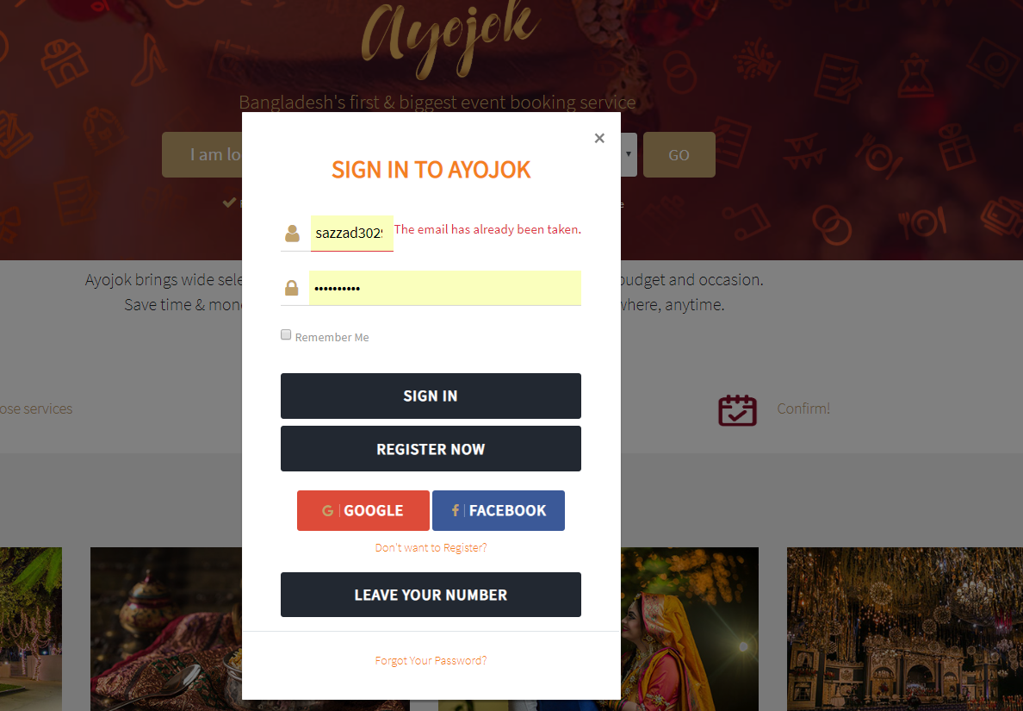

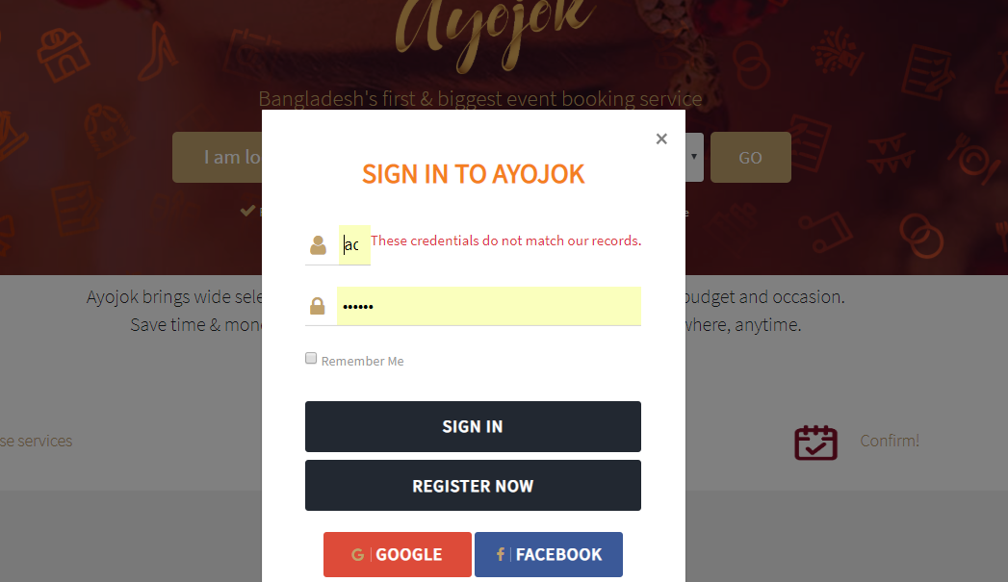

This error message show until new reload the whole page. [Solved]

**Login**:

1. **Facebook login**: ok
2. **Google login**: Irregular behavior [sometimes perfectly login, sometimes not.]
   1. Sign up problem [don’t give permission to new user]
      1. Cause still undefined.
   2. Login ok.
3. **Normal login**: ok

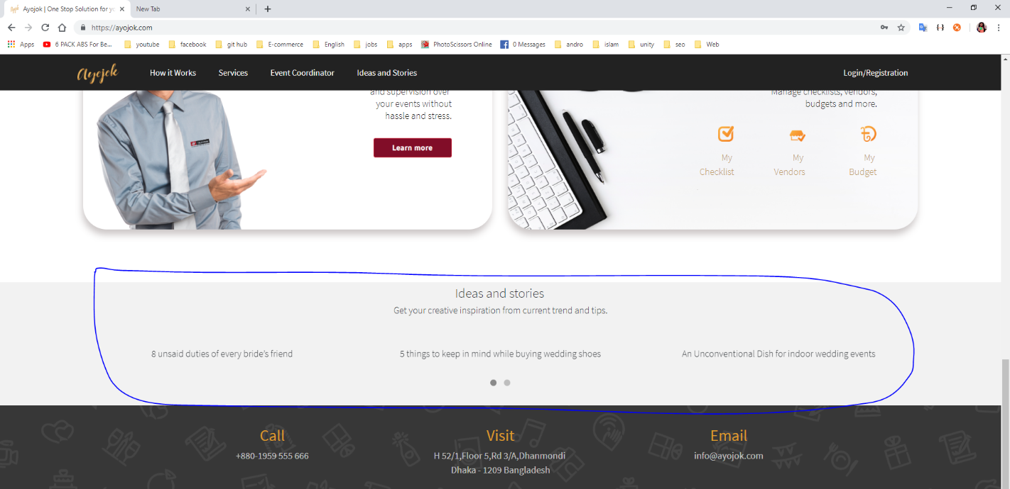

Idea and Stories : Wordpress Blog … [Javed Bhai]

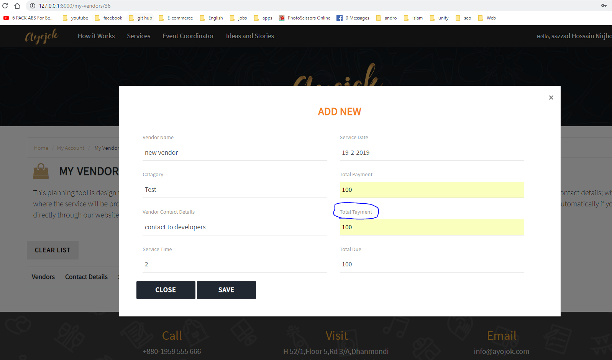

My vendor -> add new vendor? [Need explanation]

My Checklist [explanation]? [How it works I have no idea.]

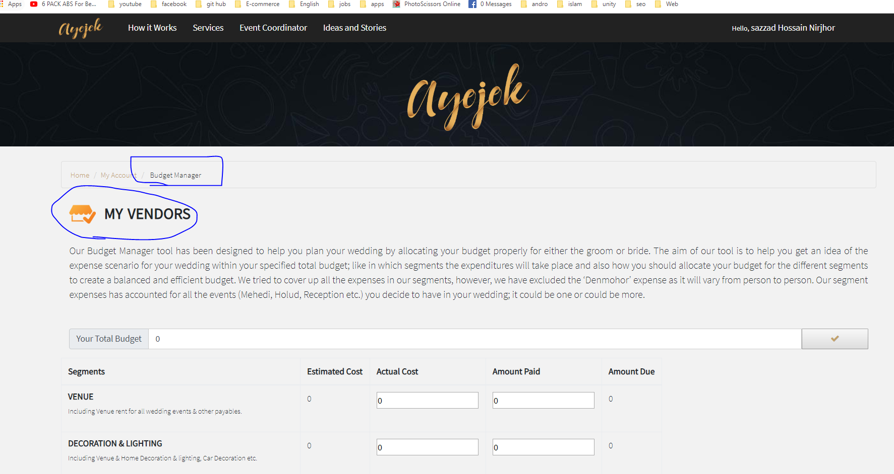

Budget Manager -> [Solved]

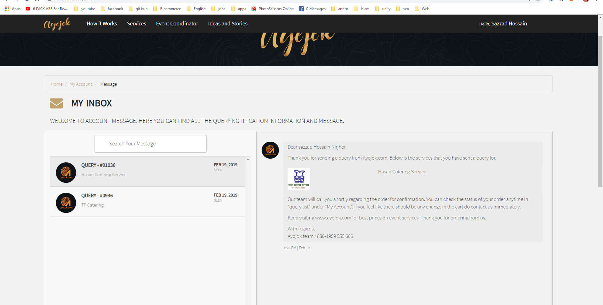

There is no option for deleting user inbox…. [No need to solved – Sajal bhai]

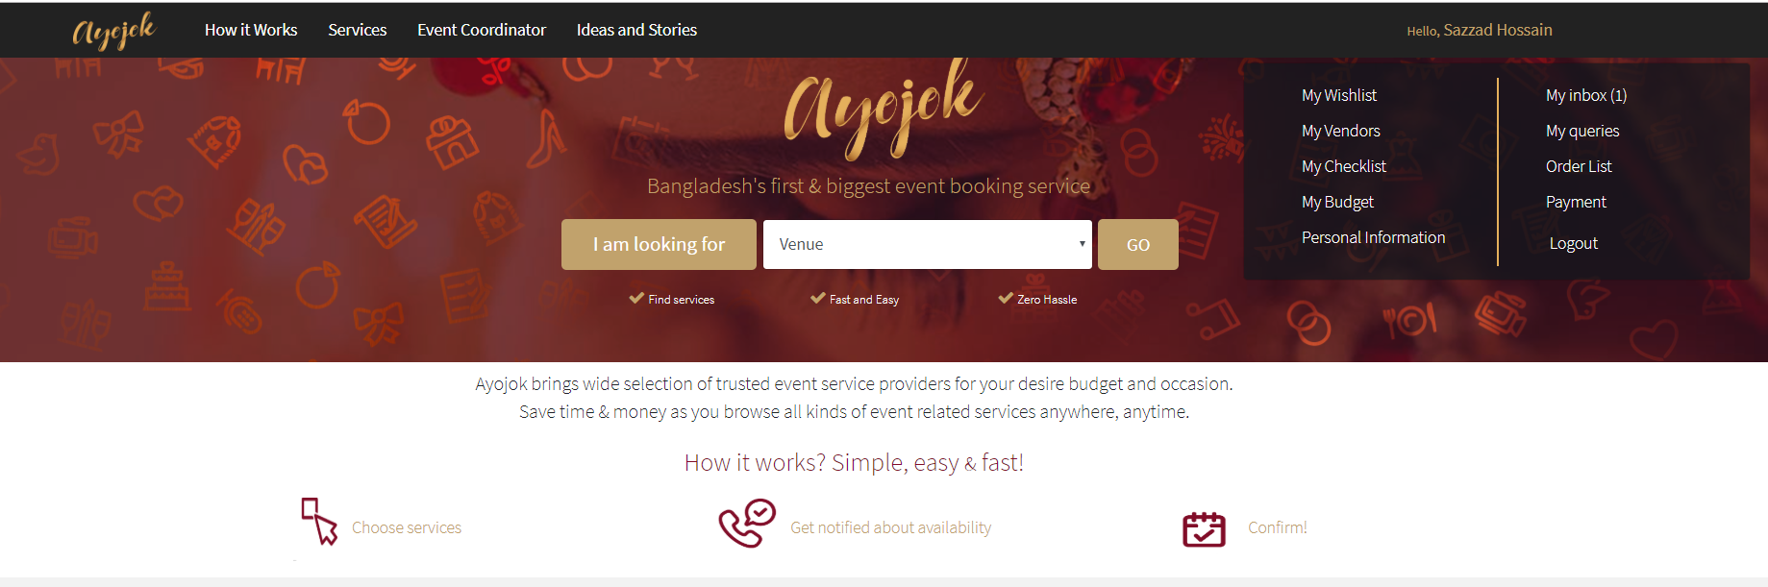

There is no notification system for user to know if admin confirm their query or not? [Solved]

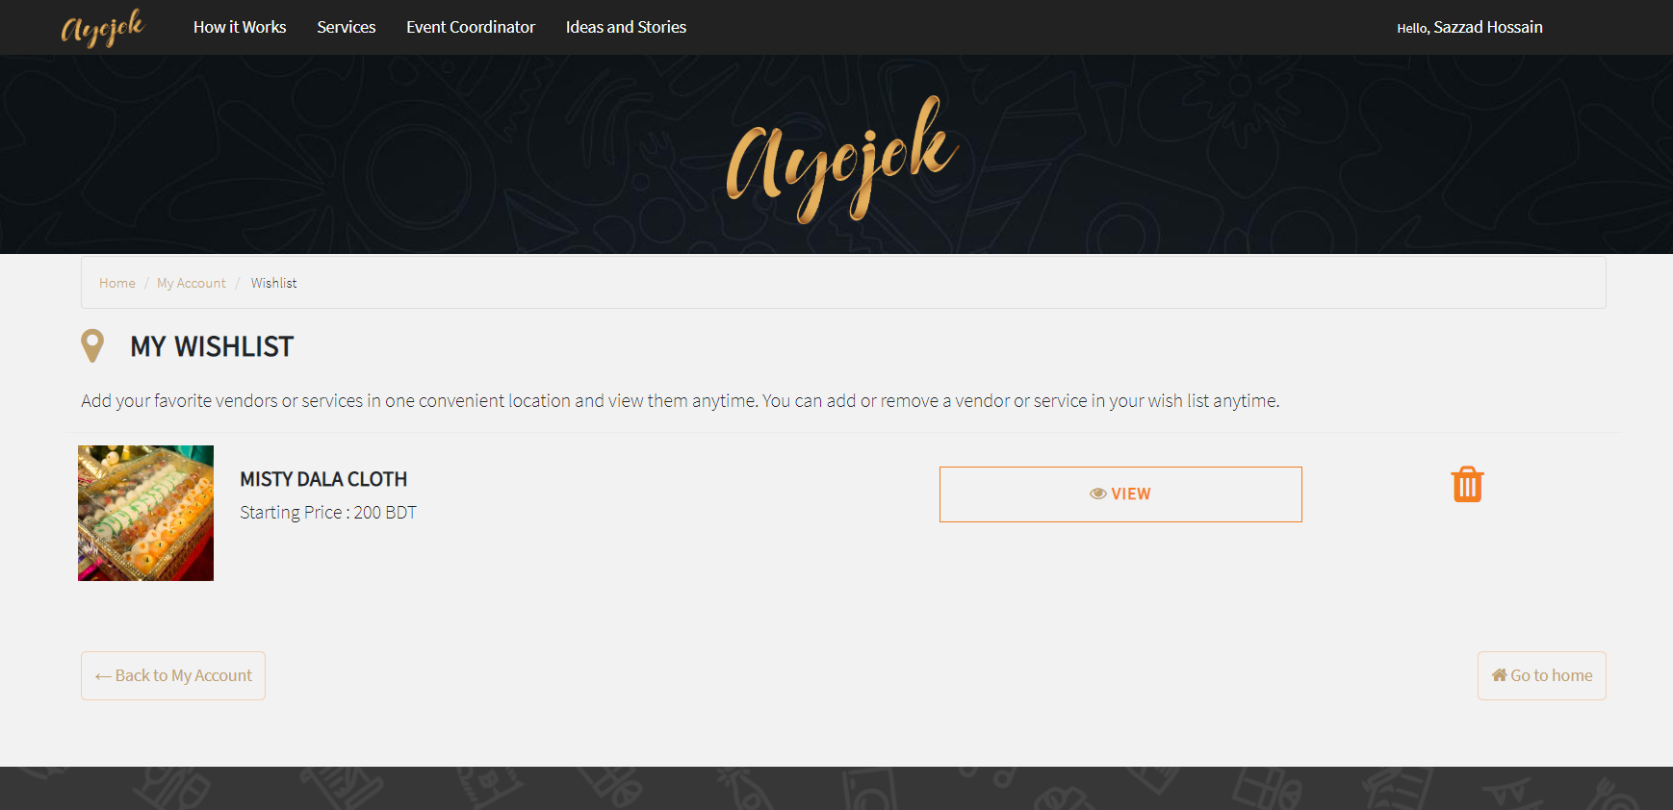

After send the query from the wish list still the list not empty until user delete it personally [No need to solved – Sajal bhai]

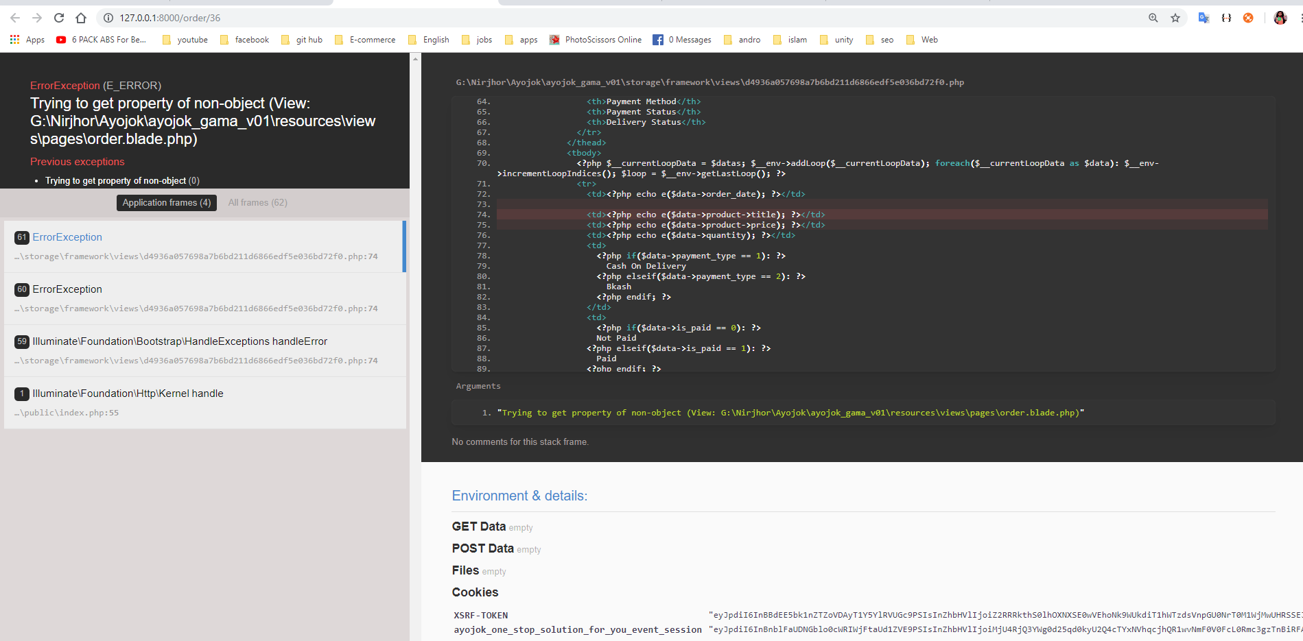

Order list of user. => it is ok when client order any services [Ayojok own] .

No ok when client order any products [any vendor’s product].

[Solved]

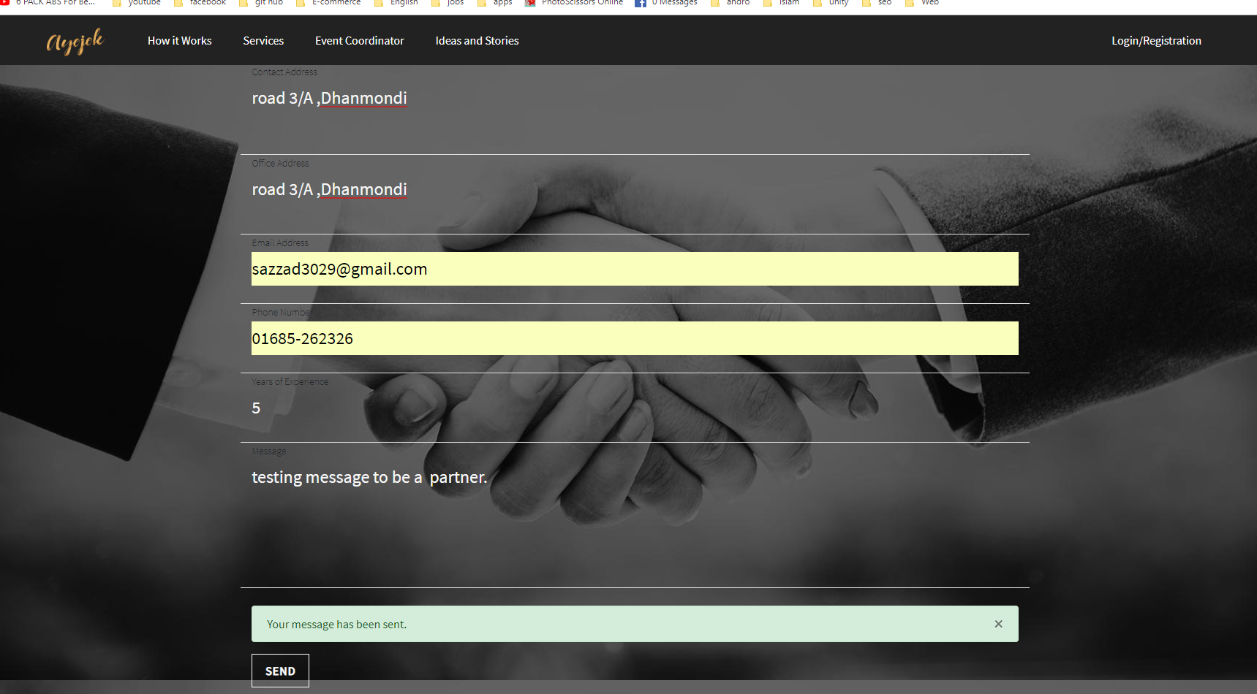

After sending message <https://ayojok.com/partners> page will remain same not reset … [Solved]

**Admin’s-end:**

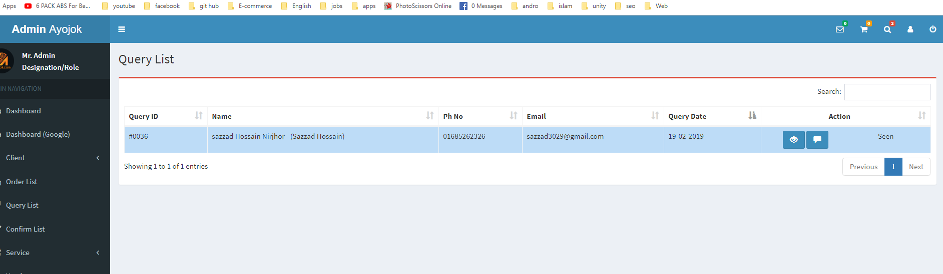

Same user multiple queries send -> seen/Unseen problem. [Solved]

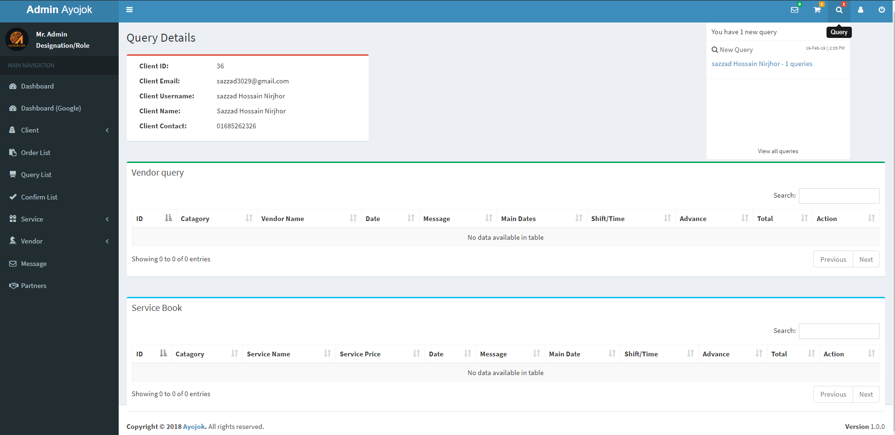

If we confirm any query then it will delete that client from the query list But

When we delete any query then it will not delete that client from the query list. Which makes confusing situation for the admin.

But when client delete that query. It will delete that client from the query list.

[No need to solve – sajal bhai]

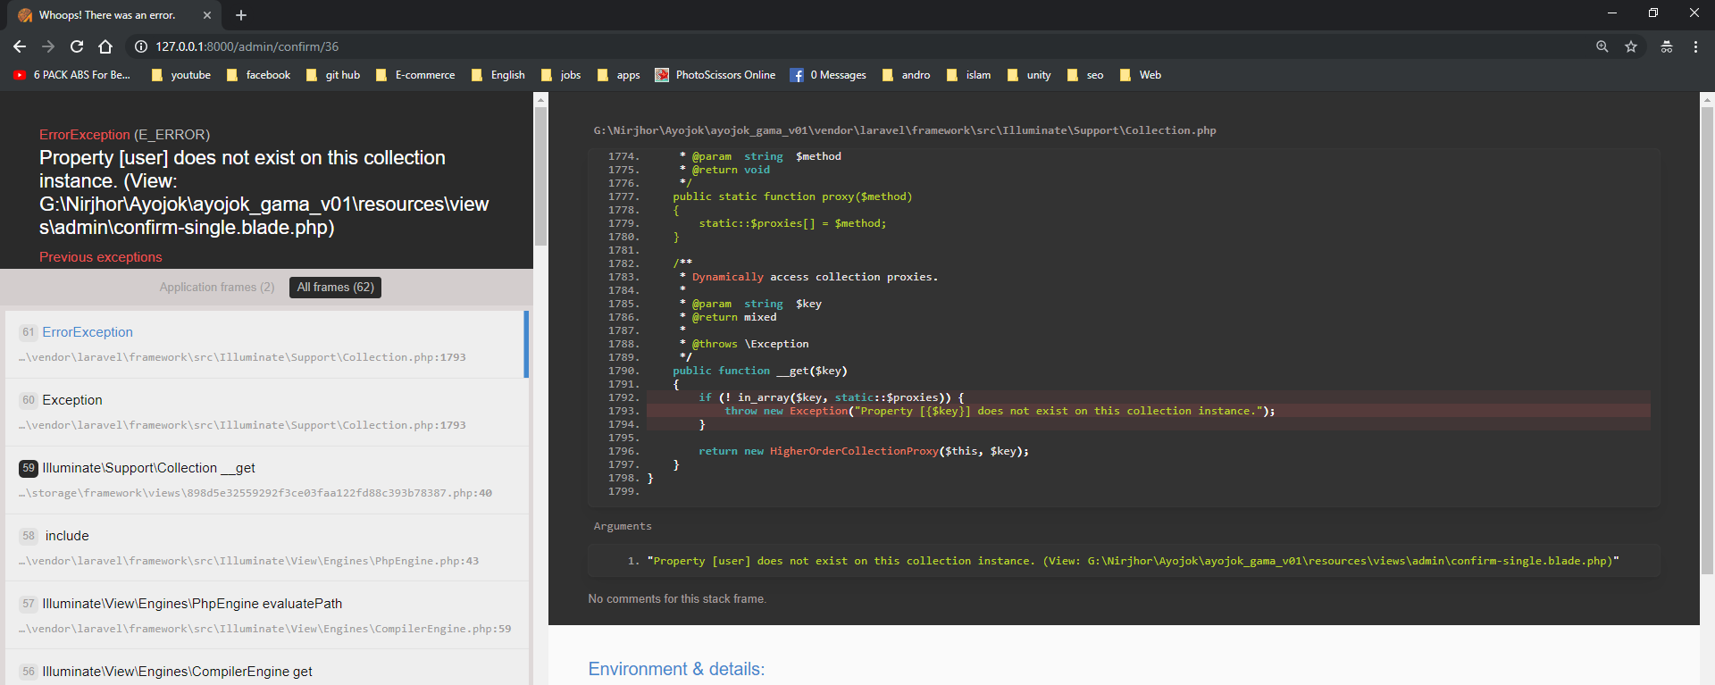

Confirm list => if any client don’t set their first name and last name. Then this error will happened...[Solved]

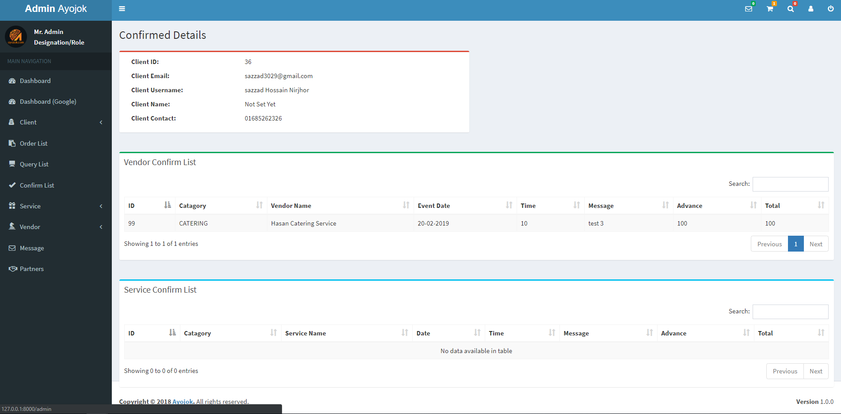

No Action in confirm query detail single.

1. Server Managing:
   1. Data Backup + Image Backup.
   2. Security issues [EX: DDOS Attack Or multi hitting problem from a single device or *IP* ]
   3. …

**Now: what’s next to do [for better performance or view]**

**User-end:**

**Admin-end:**

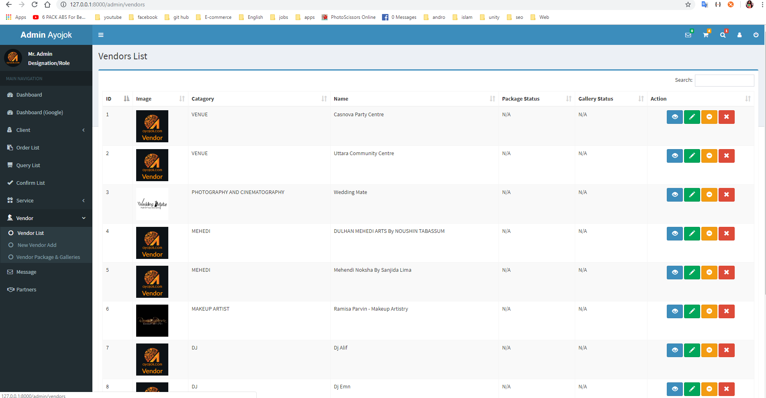

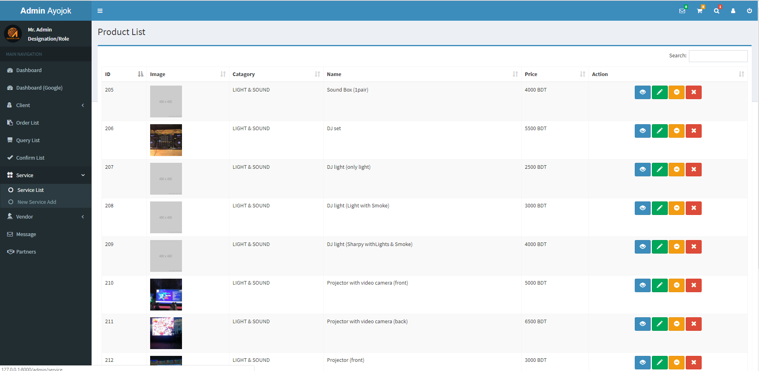

**There is no categorized section for better managements. [Solved ]**